150 ps all-optical switching in silicon microring resonators

C. J. Oton, J. Herrera, P. Sanchis, A. Martínez and J. Martí
Valencia Nanophotonics Technology Center
Universidad Politecnica de Valencia
Valencia, Spain
E-mail: coton@ntc.upv.es

We report a silicon-based optical switch controlled by a pump beam which copropagates with the signal beam. The modulator has an extinction ratio of 10dB, and a 1/e temporal response of 150 ps, with pump peak powers of 390 mW. The device is based on free-carrier dispersion effect produced by carriers generated through two-photon absorption.
Keywords: nonlinear silicon photonics; all-optical modulation; optical switch;

Introduction
Integrated silicon-based optical devices have recently emerged as a feasible technology to route, switch and modulate signals in optical networks, which are expected to dramatically reduce device costs and provide new functionalities [1]. Electrically-controlled high speed modulators have been demonstrated in the last years, most of them based on carrier injection and depletion [2]. All-optical modulators have been demonstrated too [3,4], although speeds above 1Gbps are difficult to achieve due to the carrier recombination time, which usually is in the nanosecond range. One strategy to attain high speeds consists of depleting the carriers electrically [5]. Other works have recently reported high speed optical switching without the need of electrical carrier depletion, by using polysilicon [6] or oxygen-implanted silicon [7] as guiding material. These materials are richer in recombination centers that shorten the carrier recombination time. However these works only report measurements in structures pumped from above at 800nm, which is unsuitable for an actual device. In this work, we report a high speed device where the pump copropagates with the signal and does not require electrical carrier depletion.
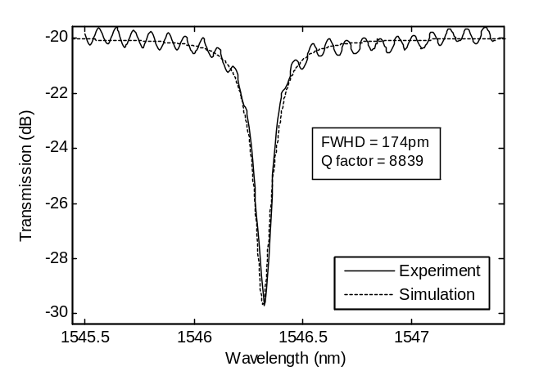
Figure 1. Transmission spectrum of the ring resonator sample (TM polarization). Solid line is the experimental data and dashed line is the result of the simulation when setting propagation loss to 30dB/cm and coupling coefficient to 16%.

Fabrication and Experiment
The samples were fabricated from SOI wafers with 3 µm buried oxide and 250 nm silicon layer. The waveguides were patterned with e-beam lithography and etched with an inductively coupled plasma (ICP) etcher. The structures were covered with 2µm of silica after SEM characterization. The channels are 500 nm wide and 250 nm high, and are coupled to 20µm-radius rings through a 300 nm gap.
Light was coupled into the waveguides by butt-coupling with lensed fibers, and was extracted with an objective. The TM transmission spectrum was measured by tuning the laser, and the result is shown in Fig. 1, where one resonance is shown. The response was fitted to the theoretical equation [8] by using the propagation loss and coupling coefficient as parameters. A good agreement was found for propagation loss of 30dB/cm and coupling coefficient of 16%. Full width at half depth (FWHD) of the peak was 174 pm, which corresponds to a Q-factor of 8839.
This work has been sponsored by the Spanish Science and Innovation Ministry through contracts SINADEC (TEC2008-06333) and DEMOTEC (TEC2008-06360).
The setup for the nonlinear characterization is shown in Fig. 2. A tunable laser was modulated with a LiNbO₃ modulator and amplified through Er-doped fiber amplifiers (EDFAs). The pulse train was generated with a 40Gb/s bit pattern generator, where pulses had 25 ps duration and 1.6 ns period. The peak power coupled into the waveguide was estimated to be 390mW. A continuous-wave (cw) probe signal was mixed with the pump with a 3dB coupler and sent to the waveguide through the same fiber with an estimated coupled power of 0.5 mW. Wavelengths of pump and probe signals were respectively 1564 and 1554 nm, chosen to match with two resonances of the microring resonator. The output signal was filtered to remove the pump component and amplified before sending the signal to a 50 GHz photodiode and collecting the data with a 40GHz sampling scope.

Results and discussion
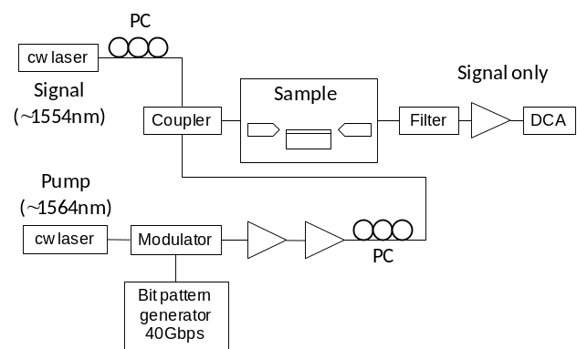
Figure 2. Setup for nonlinear characterization. Triangles represent EDFAs with ASE filters, PC stands for polarization controller, and DCA for digital communications analyzer.
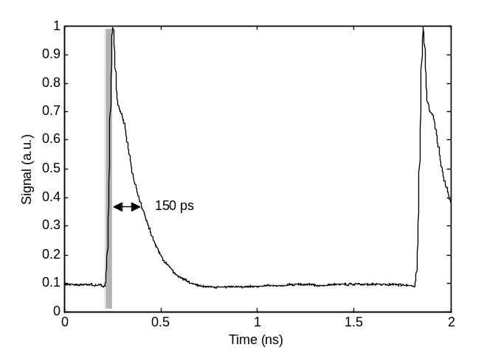
Figure 3. Variation of the probe signal when both pump and probe are resonant with two different modes of the microring. The grey box marks the pump duration.
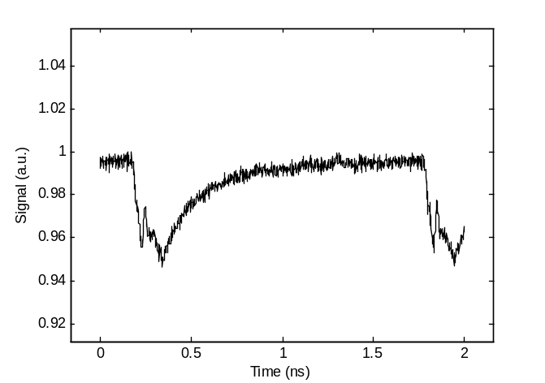
Figure 4. Variation of the probe signal when both pump and probe are out of resonance. Note that the amount of variation is only 5%.

Figure 3 shows the modulation in the probe signal produced by the pump when both pump and probe are resonant with the microring. Extinction ratio is 10.2 dB and the 1/e recovery time is 150ps. The reason for the modulation is carrier generation through two-photon absorption (TPA), which produces a decrease of refractive index that blueshifts the resonance, taking the cw probe from a resonant to a non-resonant regime.
Figure 4 shows the modulation of the cw probe signal when probe and pump are both out of resonance. The variation of signal, which is only 5%, is due to a combination of free carrier absorption (FCA) and dispersion (FCD), as the Fabry-Pérot fringes convert phase variations into weak intensity variations. An approximate value of the carrier recombination time was extracted from the 1/e recovery time, which is 225 ps. This recombination rate is quite faster than values previously reported [3,4], and defects is the most likely cause. Whether these defects are surface recombination centers or produced by the electron bombardment during SEM is currently under investigation.

Conclusions
We experimentally demonstrate an integrated all-optical switch based on free carrier dispersion effect with a switch time of 150 ps. The device uses a microring resonator to enhance the nonlinear effect and to commute the signal, producing ~10dB of extinction ratio.

References
- R. Soref, "The past, present, and future of silicon photonics" IEEE J. Sel. Top. Quantum Electron. 12 (6), pp. 1678-1687 (2006).
- D. Marris-Morini, L. Vivien, G. Rasigade, J.-M. Fedeli, E. Cassan, X. Le Roux, et al, "Recent Progress in High-Speed Silicon-Based Optical Modulators," Proceedings of the IEEE 97 (7), pp.1199-1215 (2009).
- V. R. Almeida, C. A. Barrios, R. R. Panepucci et al., "All-optical control of light on a silicon chip" Nature 431, pp. 1081-1084 (2004).
- Q. F. Xu and M. Lipson, "All-optical logic based on silicon micro-ring resonators" Opt. Express 15 (3), pp. 924-929 (2007)..
- S. R. Preble, Q. F. Xu, B. S. Schmidt, and M. Lipson, "Ultrafast all-optical modulation on a silicon chip" Opt. Lett. 30 (21), pp. 2891-2893 (2005).
- K. Preston, P. Dong, B. Schmidt, and M. Lipson, "High-speed all-optical modulation using polycrystalline silicon microring resonators" Appl. Phys. Lett. 92 (15), p. 151104 (2008).
- M. Waldow, T. Plötzing, M. Gottheil, M. Först, J. Bolten, T. Wahlbrink, and H. Kurz, "25ps all-optical switching in oxygen implanted silicon-on-insulator microring resonator" Opt. Express 16 (11), pp. 7693-7702 (2008).
- J. Heebner, R. Grover, T. A. Ibrahim, “Optical microresonators” Springer Series in Optical Sciences Vol. 138, Springer-Verlag, London 2008.

